Dumfries and Galloway Kickstart Opportunities

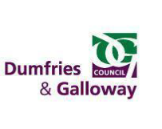
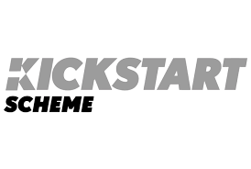

Are you aged 16-24, thinking about a career in Youth Work, claiming Universal Credit and looking for paid work experience to help you get into employment?

Link Worker (Kickstart Scheme)
Dumfries and Galloway Council in partnership with Kickstart have the ideal opportunity for you.
Brief description of role
You will be part of a team committed to delivering high quality person-centred services based on the principles of self-directed support, 'The keys to life' and Health & Social Care Standards. Reporting to a Support Co-Ordinator, you will provide direct care and support and contribute towards personal planning and reviews, team meetings and recording of electronic information.
Location and no. posts
There are three placements in Castle Douglas.
Training and future job prospects
Successful applicants will get the chance to work alongside staff to gain experience, also including the opportunity to:
•Access high quality training opportunities (where appropriate)
•Work experience
•Gain qualifications
•Knowledge and Skills Development
•1:1 support
Employability support will be provided by an Employment Key Worker from the Dumfries & Galloway Council, Employability & Skills Service. The support will include:
• looking for long-term work and setting goals
• support with curriculum vitae (CV) and interview preparations
• developing their skills in the workplace
• accessing the Work Based Skills Award (SQA accredited) where appropriate
How to apply
If this sounds like the opportunity for you, get in touch with your local work coach at DWP who can advise and support your application. These jobs are only available by registering with DWP.
Closing Date
Closing date to be confirmed
For more information or to ask about the process contact:
Marie McKeown (Marie.McKeown@dumgal.gov.uk) Registering for Universal Credit

#YPGuarantee #DGDYW #SupportDG #Employability #WorkReady
#Vacancies #EmploymentSupport #DG Kickstart #ESS

