Dumfries and Galloway Kickstart Opportunities

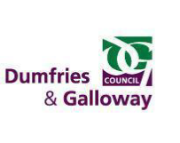
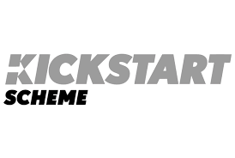

Are you aged 16-24, thinking about a career in Youth Work, claiming Universal Credit and looking for paid work experience to help you get into employment?

Youth Worker (Kickstart)
Dumfries and Galloway Council in partnership with Kickstart have the ideal opportunity for you.
Brief description of role
This role involves you assisting the Community and Learning Development workers in the planning, development and delivery of youth provision, in response to the local needs of young people and the Children, Young People and Lifelong Learning Workplan.

The duties involve evening and weekend work, and you working directly with young people to promote and develop a young person led curriculum which maximises opportunities for social and personal development.

Location and no. posts
There is one placement throughout various locations of Annandale and Eskdale.

Training and future job prospects
In this role you will be supported on a 1:1 basis and gain valuable work experience, develop your knowledge and skills and work towards the achievement of a professional development award in Youth Work (SQA accredited).

How to apply
If this sounds like the opportunity for you, get in touch with your local work coach at DWP who can advise and support your application. These jobs are only available by registering with DWP.
Closing Date
08/07/2021
For more information or to ask about the process contact:
Jill Hima (Jill.Hima@dumgal.gov.uk) Marie McKeown (Marie.McKeown@dumgal.gov.uk) Registering for Universal Credit

#YPGuarantee #DGDYW #SupportDG #Employability #WorkReady
#Vacancies #EmploymentSupport #DG Kickstart #ESS

